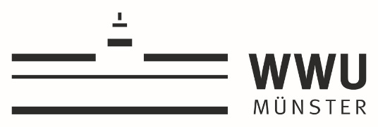

Collaboration Grants 2021-2022

APPLICATION FORM

Project title:

Applicants
Applicant | Faculty/Unit | Name/position contact person
- UT Partner
- WWU Partner

Description (up to 2 pages)
- Introduction
- Key objectives
- Core activities
- Timeline
- Results/outcomes
- Exploitation plan

Motivation (up to 8 pages)

Scientific Quality and Innovation:

What is the history and innovative features of the collaboration?

Why is joint expertise of both partners essential?

How does the collaboration valorize synergies between the teams involved?

Strategy:

Why is the project relevant for the strategic partnership of UT and WWU? Please describe a short- and mid-term perspective.

How will the project contribute to the strategic aim of strengthening the international reputation and standing of both universities? Please describe possible access to new (inter)national networks and/or stakeholders.

Prospective Funding: Please describe intended follow up projects and opportunities to obtain third party funding.

Other:

Financial proposal
Budget items | EUR
1.
2.
3.
4.
Total requested budget

