Understanding the Imaging Process and Role of Illumination in Finger Vascular Pattern Recognition

Introduction
This report is a research summary of Pesigrihastamadya Normakristagaluh as a Ph.D. candidate at the Data Management and Biometrics (DMB) research group, Faculty of EEMCS, the University of Twente. The research is supervised by Prof. Dr. R.N.J. Veldhuis (Raymond) and Dr. L.J. Spreeuwers (Luuk). This Ph.D. research is funded by the Ministry of Research, Technology, and Higher Education of the Republic of Indonesia and supported by the National Research and Innovation Agency (BRIN), Indonesia.
Finger vein recognition as a promising biometric technique has drawn increasing attention from the biometrics community in recent years. Compared with other biometric traits, e.g., fingerprint, face, or iris, finger-vein characteristics cannot easily be copied, leave no traces, and are convenient to use. These benefits encourage the use of finger vein recognition in various security applications, and several methodologies for obtaining discriminative characteristics for high recognition performance have been developed. Since both arteries and veins are recognized, the term "finger vascular pattern recognition" is a better name than "finger vein recognition". However, we will continue to use the term “finger vein recognition” because it is widely used. This research is about developing a better understanding of the imaging process and the role of illumination in finger vascular pattern recognition.

Research Background
Finger vein imaging systems that employ the near-infrared (NIR) spectrum have been developed in various ways [1]. Obtaining good-quality vascular patterns in practice is quite challenging since the images may be blurred and have different intensity areas and varying contrast. In explaining the imaging process, the literature on finger-vein recognition does not go beyond the premise that the hemoglobin in the blood absorbs the light, while the other tissues scatter it. One common claim is that strong scattering of light in biological tissues during imaging is the main cause of contrast deterioration in finger-vein images [2]. The explanation of image formation is usually not very detailed. Our research presents a model to obtain a better understanding of imaging of finger vein patterns and the role of illumination in the imaging process. It can be used to improve the acquisition device, resulting in improved image quality and recognition performance.

Research Problem
The research questions related to this research problem are the following:
- How can the imaging process be modeled, and how does this help to interpret the images?
- What are the roles of the bone, soft tissues, blood vessels and joints?
- How can this knowledge be used to create phantom fingers that help analyze the imaging process?
- How can this model be used to obtain a better understanding of the role of illumination in the imaging process?
- What is the impact of illumination width on generating finger vein patterns?
- How does the direction of illumination impact the development of finger vein patterns?

Since the imaging process seems to be a cause of the poor image quality, developing a physical model could help us to get a better understanding of image formation. A physical model describes the illumination process to acquire knowledge about the contribution to the imaging process of each part inside the finger. It can also help us understand why the finger vein images are brighter near the joints. A commonly accepted explanation for this in finger vein recognition (FVR) is that the bone tissue in our fingers tends to block the light more than the other parts, and the light passes through the joints [3]. However, we found that this explanation was incorrect, and we provide a better explanation for this phenomenon.
To make finger vein patterns visible in the NIR spectrum, three types of illumination (top-transmission, 2-sided illumination, and reflection) are used for illuminating the finger. Although the illumination methods differ, the resulting finger-vein images show similar characteristics. We found that vascular patterns from different types of illumination are very similar, but the contrast saturation is different. The effect of illumination on the image quality of finger vein images for finger vein recognition has yet to be thoroughly investigated. Near-infrared (NIR) light-emitting diodes (NIR LEDs) with various broad opening angles, for example, have been widely employed in finger vein scanners instead of visible light. To the best of our knowledge, relatively few researchers have attempted to quantify the impact of illumination bundle width on the finger vascular pattern imaging process. In our research, we present new results on the impact of illumination bundle width and illumination direction on the NIR image quality of the finger vein and the performance of finger vein recognition (FVR).

Work & Results
Our findings show that the NIR light is scattered by the bone, acting as a diffuser, and the NIR light is absorbed by the blood and soft tissue, where the blood's hemoglobin has the strongest absorption. We create a phantom finger (see Fig 1) to mimic a real finger as an implementation of the physical model. It is used in the simulation of the NIR imaging process. This phantom can enhance finger vein visualization and feature extraction with realistic images that include ground truth information for vein patterns. Furthermore, we found that brighter areas surrounding the finger joints are caused by thinner soft tissues around the joints absorbing less light. The bone tips in the joints may appear slightly darker, but it is not a significant effect. Moreover, we found that fluid present in the joints does not have any impact on the imaging process.

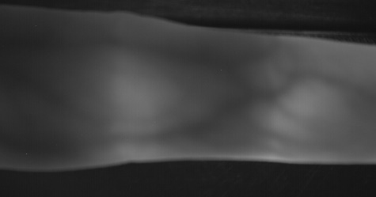 | 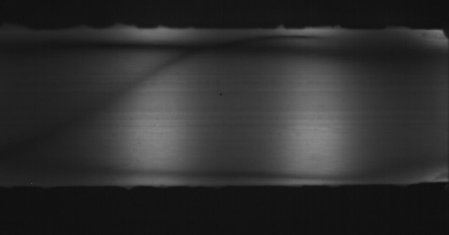  b) | 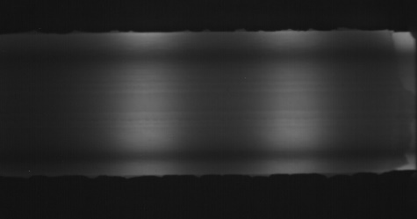
Fig 1. Example of captured: a). real finger, b) phantom finger with and c) without vein’s replica.
c)
a)

We propose a qualitative theoretical model based on these observations. The result is that only blood vessels close to the skin are visible by their projected shadows on the surface of the finger. The model allows us to predict the effect of illumination on the finger vein images: the pattern is independent of the direction of the illumination, while illumination with a narrow beam improves image quality due to reduced risk of overexposure. Since the bone acts as a light diffuser in the image projection of finger vascular patterns, homogenous illumination along the finger does not require a large spread angle. However, it is sufficient to illuminate the finger using a narrow beam (e.g., a laser). We present a series of experiments to validate the predictions using illumination from different directions and beam widths. For these experiments, we collected a highly controlled dataset with minimal rotations and translations of the fingers between sessions. Figure 2 shows an example of the captured finger by our design devices (UTFVPRv3 scanner). We apply the maximum curvature for feature extraction of finger vascular pattern and comparison method by Miura et al. [4]. All experiments support the model, as is ultimately shown by an experiment that compares images obtained with top illumination to images obtained with left+right illumination and narrow beams. This results in a similar recognition performance as the top illumination, clearly demonstrating that the vein patterns do not depend on illumination direction, and illumination using narrow beams results in significantly better image quality and recognition performance.

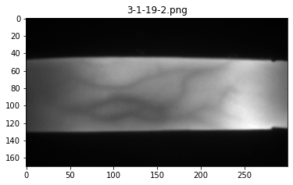  a) | 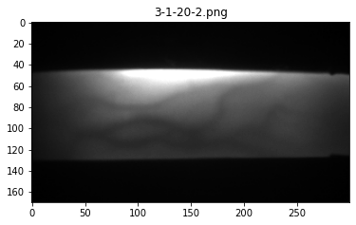  b) | 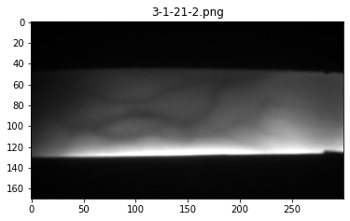  c)
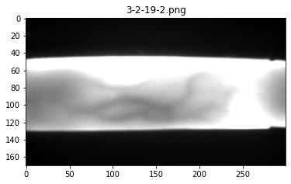  d) | 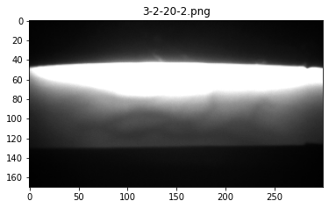  e) | 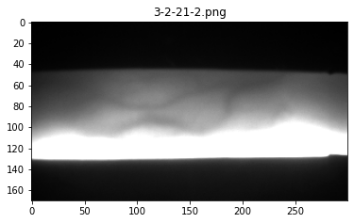
Fig 2. Examples of the same finger captured: using narrow-beam NIR-LEDs with direction from a) top, b) right, c) left side, and using wide-beam NIR-LEDs with direction from d) top, e) right, f) left side.
f)

Conclusion
Our research presented two types of models: a physical model and a qualitative theoretical model. These models can be used to enhance image quality and improve the performance of finger vein recognition. The contributions of our research are:
- Bone plays the main role in the imaging process, acting as a NIR light scatter, while blood and soft tissues absorb it, with hemoglobin in blood being the most absorbent.
- The proposed physical model leads to a better understanding of the illumination process, in particular around the joints.
- The presentation of a phantom finger that is capable of generating a realistic image with ground truth.
- A qualitative theory explains the projection of blood vessels close to the skin as shadows on the finger surface, allowing us to predict the impact of illumination widths and directions on finger vascular pattern imaging and recognition.
- Narrower bundles of light do not affect which veins are visible, but they reduce the overexposure at finger boundaries and increase the quality of vascular pattern images.
- Top illumination performs well because of a more uniform with less overexposure at finger boundaries, which results in more visible veins.
- Illumination with various direction can be interoperable since they produce the same vascular pattern.
- The projected vein patterns are independent of illumination direction.
- A clean, controlled dataset that has a consistent position of the finger, minimizes longitudinal finger rotation.

Research Publication
- Normakristagaluh, P., Spreeuwers, L. J., & Veldhuis, R. N. J. (2018, May). “A Prototype of Finger-vein Phantom”. In 39th Symposium on Information Theory and Signal Processing in the Benelux 2018 (pp. 163-166). Werkgemeenschap voor Informatie-en Communicatietheorie (WIC).
- Normakristagaluh, P., Spreeuwers, L. J., & Veldhuis, R. N. J. (2019, May). “Finger-vein Pattern Recognition Based on ICP on Contours”. In 40th WIC Symposium on Information Theory in the Benelux 2019 (pp. 97-101). KU Leuven.
- Normakristagaluh, P., Laanstra, G. J., Spreeuwers, L., & Veldhuis, R. (2022). “Understanding and modeling finger vascular pattern imaging”. IET Image Processing, 16(5), 1280-1292.
- Normakristagaluh, P., Laanstra, G. J., Spreeuwers, L., & Veldhuis, R.. “The impact of illumination on finger vascular pattern recognition”. Accepted in IET Biometrics, (2024).
- Spreeuwers, L. J., Grift, R. V. D., Normakristagaluh, P. "3D Printed Realistic Finger Vein Phantoms." ArXiv, 2023, /abs/2309.14806. https://doi.org/10.48550/arXiv.2309.14806. Accessed 27 Sept. 2023.

References
- Uhl, A., Busch, C., Marcel, S., & Veldhuis, R. (2020). Handbook of vascular biometrics (p. 533). Springer Nature.
- Yang, J. and Shi, Y. (2014). Finger-vein network enhancement and segmentation. Pattern Analysis and Applications, 17(4):783–797.
- Yang, J., Shi, Y.: Towards finger-vein image restoration and enhancement for finger-vein recognition. Inf. Sci. 268, 33–52 (2014).
- Miura, N., Nagasaka, A., Miyatake, T.: Extraction of finger-vein patterns using maximum curvature points in image profiles. IEICE TRANSACTIONS on Information and Systems 90(8), 1185–1194 (2007).

