IMPACT CASE TEMPLATE

ABOUT THIS TEMPLATE
This template was first set up for an impact cases workshop at the High-tech Business and Entrepreneurship (HBE) department at the faculty of Behavioural Management and Social Sciences (BMS) of University of Twente in January of 2024. The template builds on work by University of York, University of Bath, University College Dublin and Nyenrode University.

Contributors:
- Dr. Letizia Alvino (HBE-ETM)
- Ir. Tom Boogerd (Research Support Office)
- Prof. Dr. Louise Knight (HBE-ETM)

Last edit: May 2024

WRITING TIPS
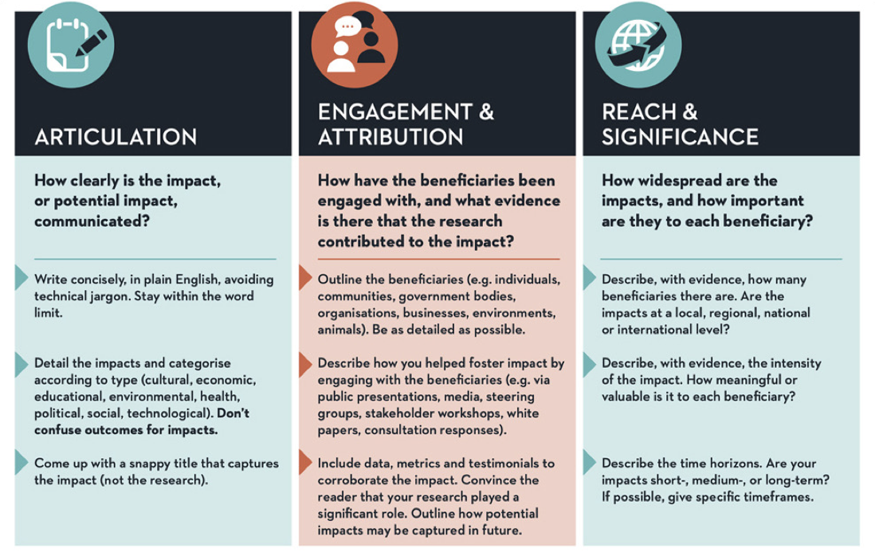Source: UCD Dublin

VOCABULARY TO REFLECT ON YOUR IMPACT
The BMS Position Paper on Impact aims to describe what impact means for BMS, the (type of) impact we aim to make and how, while at the same giving vocabulary to further explore what impact means in your own work. A key part of this is adopting Impact by Design as working method, contextualised by a set of 10 guiding principles.

Link to online version. You can also find the paper yourself on the BMS Research Support Website, under the Impact heading or request a copy at Tom Boogerd.

Template starts on next page

WRINTING YOUR IMPACT CASE

A. GENERAL INFORMATION

Author name(s):

Other contributors/partners:

Month and year of writing this case:

Title of the Impact Case:

B. EXECUTIVE SUMMARY OF THE IMPACT CASE

Approximately 150 words. You are advised to work on section C first.

This section summarises the “impact case”. You should start by writing Section C and then move back to section B.

You can summarise your case by explaining:
- What is/was your project/work about?
- What new knowledge and insights were generated?
- Which communities/stakeholders were impacted by your efforts and how?

Focus on the change that has occurred (impact). Be bold and focused. This section should briefly state what specific impact is being described in the case study.

------------------------------------------------------------------------------------

C. DISCUSSION OF THE IMPACT

Approximately 500 words.

The following question provide a guideline to define your impact case:

- Topic. Describe your topic. Specify if this is the result of a single project or a combination of multiple projects with a shared goal. What was your contribution to the project(s)? Were other partners/parties involved? How long did the project run (until now)?
- Uniqueness of the topic described. What makes this project/topic unique? What makes this project/topic important?
- Problem identification. What was the problem/opportunity addressed? And why is it/was a problem?
- Output. What new knowledge and insights were generated?
- Identify the relevant communities and stakeholders and outline the specific benefits they have received. Which communities/stakeholders were impacted by your efforts and how? How have they benefitted from your work? How did your impact develop over time (if possible, provide a timeline).
- Discuss Evidence. What evidence could make this explicit?

------------------------------------------------------------------------------------

D. REFERENCES GENERATED AS A RESULT OF THE RESEARCH

Include a maximum of 10 references (e.g., grants or follow-up grants, journal articles, book or book chapters, newspaper articles, given talks, …, ….). Specifically, this section should provide references to key outputs from the research described in the previous section, and evidence about the quality of the research. Preferably APA style.

You can use the Impact Indicator Inspiration Framework to get inspired by different possible measures that can underpin your story.

------------------------------------------------------------------------------------

